USER INTERFACE AND DESIGN

COMPARISION OF TWO UI DESIGNS

NAME: SANDHIYA P ROLL NO : 230701282

DEPARTMENT: CSE – C

BAD WEBSITE DESIGN

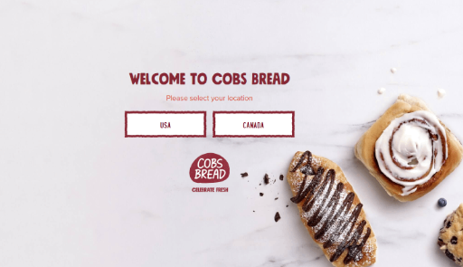

REASON WHY IT IS BAD?

1. **Low Text Contrast**: The text blends with the light marble background, making it hard to read, especially for users with visual impairments.

2. **Unclear Buttons**: The "USA" and "CANADA" buttons lack distinct borders, hover effects, or strong visual indicators, making it unclear they are clickable.

3. **Unbalanced Layout**: The placement of text, buttons, and images lacks alignment and hierarchy, leading to a disorganized and confusing user experience.

4.**Cluttered Visuals**: The background bread images are distracting and do not complement the core design, creating unnecessary clutter.

5. **No Accessibility Features**: There’s no consideration for accessibility, such as large, clear fonts, sufficient contrast, or screen reader-friendly elements.

GOOD WEBSITE DESIGN

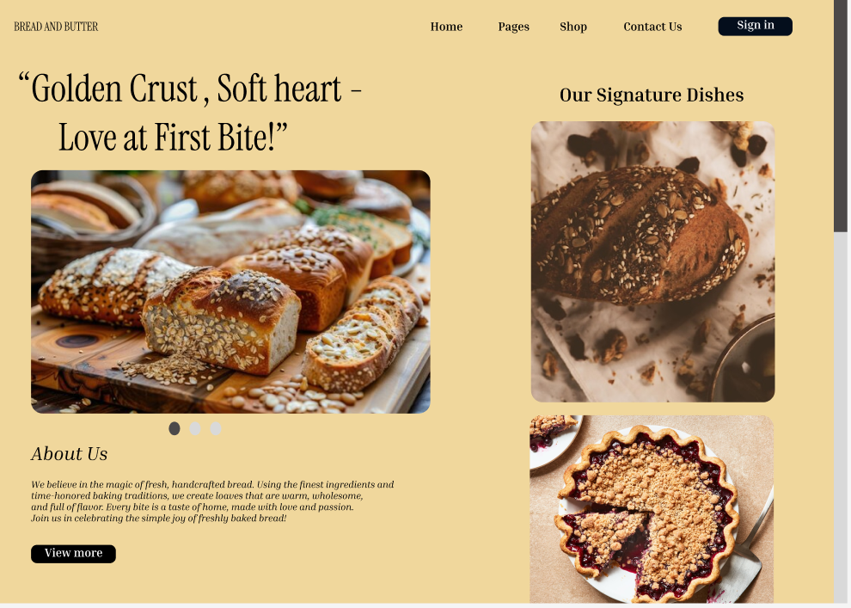

HIGHLIGHTING WHY THIS DESIGN IS SIGNIFICANTLY BETTER FROM THE PREVIOUS:

1. **Clear Visual Hierarchy**: The heading, subheading, and images are well-organized, making it easy for users to navigate and focus on key elements.

2.**High-Quality Imagery**: The bread and dessert images are vibrant and relevant, creating a visually appealing and appetizing experience.

3. **Balanced Layout**: The grid-based layout ensures a clean and structured design, avoiding clutter while showcasing content effectively.

4. **Accessible Fonts and Colours**: The contrast between text and background is sufficient for readability, and the font choice is elegant yet legible.

5. **Interactive Elements**: Buttons like "View more" are clear, actionable, and styled well to invite user interaction.